MEMORANDUM

TO: Warden and Council
FROM: Will Balser, Junior Planner, Development Officer
DATE: April 15, 2020
RE: First Reading on amendment to Land Use Bylaw to rezone PID 25337460, 467 MacDonald Road, Upper Nappan

Background: On March 16, 2020, Planning and Development staff received an application from Star Atlantic Holdings Inc. Director Rajan Chugh (the “applicant”) regarding the property at 467 MacDonald Road, Upper Nappan - PID 25337460 (the “subject property”).

The subject property is owned by Star Atlantic Holdings Inc. and is located behind the Cumberland Regional Health Care Centre, fronting on both MacDonald Road, and Burns Drive. The application is for a rezoning to permit the change in use from a Multi-unit Dwelling to commercial office spaces.

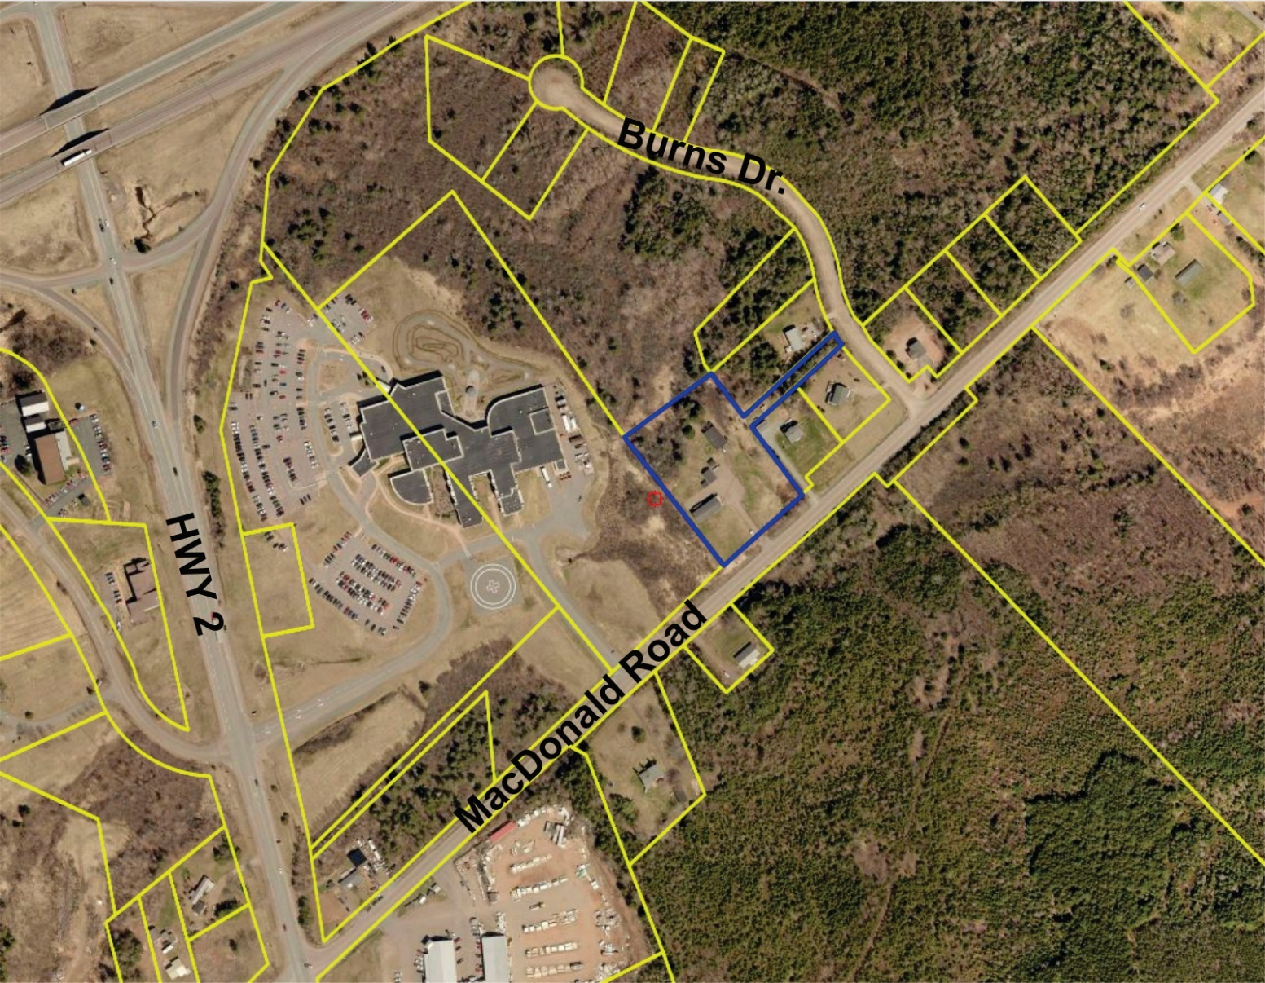
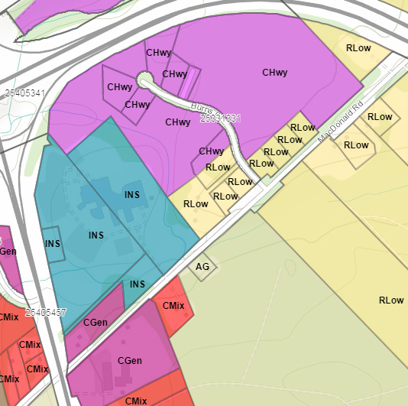
Regulatory and Land Use Context:
Current Zone: Lower Density Residential
Proposed Zone: General Commercial

The subject property is designated as Residential on Schedule A of the Municipal Planning Strategy (MPS). The current Lower Density Residential zoning of the property does not allow commercial uses without entering into a Development Agreement.

A majority of the neighboring properties are undeveloped, forested lots zoned as Agriculture [AG], Highway Commercial [CHwy] and Lower Density Residential [RLow]. There are 4 dwellings located around the intersection of Burns Drive and MacDonald Road, all zoned Lower Density Residential [RLow]. Other surrounding uses include the Cumberland Regional Health Care Centre (zoned Institutional [INS]) and Harrisons Home Hardward (zoned General Commercial [CGen]).

Rezoning the subject property to General Commercial [CGen] would allow the change in use to commercial office spaces, and is supported by Municipal Planning Strategy Policy 6-8:

“Council shall consider amendments to the map of the Land Use By-law when the proposed zoning change is not specifically prohibited within this Plan and at least one of the following two conditions
is true:

- the proposed zone is enabled by this Plan for use within the same designation; or

- notwithstanding the zones permitted within a designation, the land to be rezoned is under 5 hectares in area and is adjacent to a designation that permits the proposed zone. For clarity, land that abuts a right-of-way, such as a street, is considered to be adjacent to the designation on the other side of the right-of-way.”

In this case, the proposed zone (General Commercial [CGen]) is within the Commercial Designation and not within existing Residential Designation. However, since the subject property is under 5 hectares (~9500m2) and the adjacent Highway Commercial [CHwy] zoning is in the Commercial Designation, a rezoning can be made to any zone within the Commercial Designation.

The rezoning is also supported by MPS Policy 5-17:

“Council shall, in the Land Use By-law, establish the General Commercial Zone, intended to permit a wide range of commercial uses in an urban setting. Permitted uses shall include a very wide range of commercial uses, as well as dwellings located above or behind a groundfloor commercial use. Zone standards shall be flexible to accommodate the wide range of needs from the diversity of permitted uses.”

Next Steps: If the amendment passes first reading, staff will prepare advertisements for the public hearing to be held prior to second reading.

Recommendation: Give first reading to the proposed amendments to the Land Use Bylaw and call a public hearing for May 20, followed by a second reading.

Alternative: Council can decide to reject the proposed amendment, or request that further information be provided.

